29.72: a) 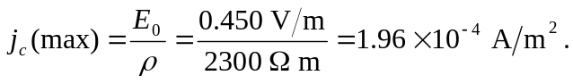
b)
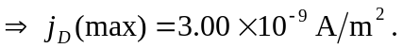
c) 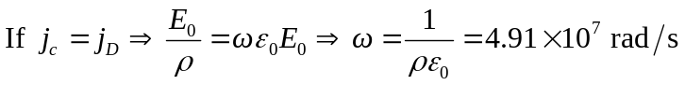
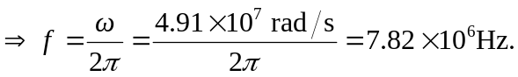
d) The two current densities are out of phase by 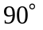 because one has a sine function and the other has a cosine, so the displacement current leads the conduction current by 